**Day 3 – E-Mail Service**

1. Research the following internet protocols related to e-mail services.
   1. SMTP Protocol
   2. POP3 Protocol
   3. IMAP Protocol
   4. Web Mail
2. Use the following resource as a starting point:  
   <https://askleo.com/what_is_pop_or_pop3_or_a_pop_account_and_what_about_smtp/>
3. Complete the following Venn Diagram to summarize your research.

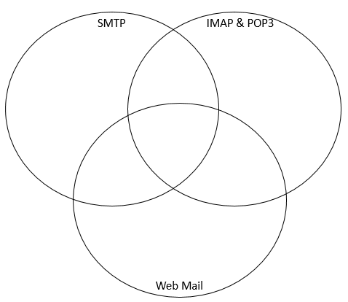

Can use apps to access emails offline

Cannot send or receive email offline

Use server to send

User accesses email on server, not locally.

POP3 Emails stores multiple copies on different devices

POP3 Emails stored locally

Protocol used for getting Emails

May download to computer

IMAP Emails stored on server

Server Looks for TCP connection

Sends almost instantly

Uses SMTP sever

Sends to ISP mail server

Email stored on server

Used on app

Uses internet

Used for Email EMEmaiEmemail

Accesses server

Protocol used for sending Emails